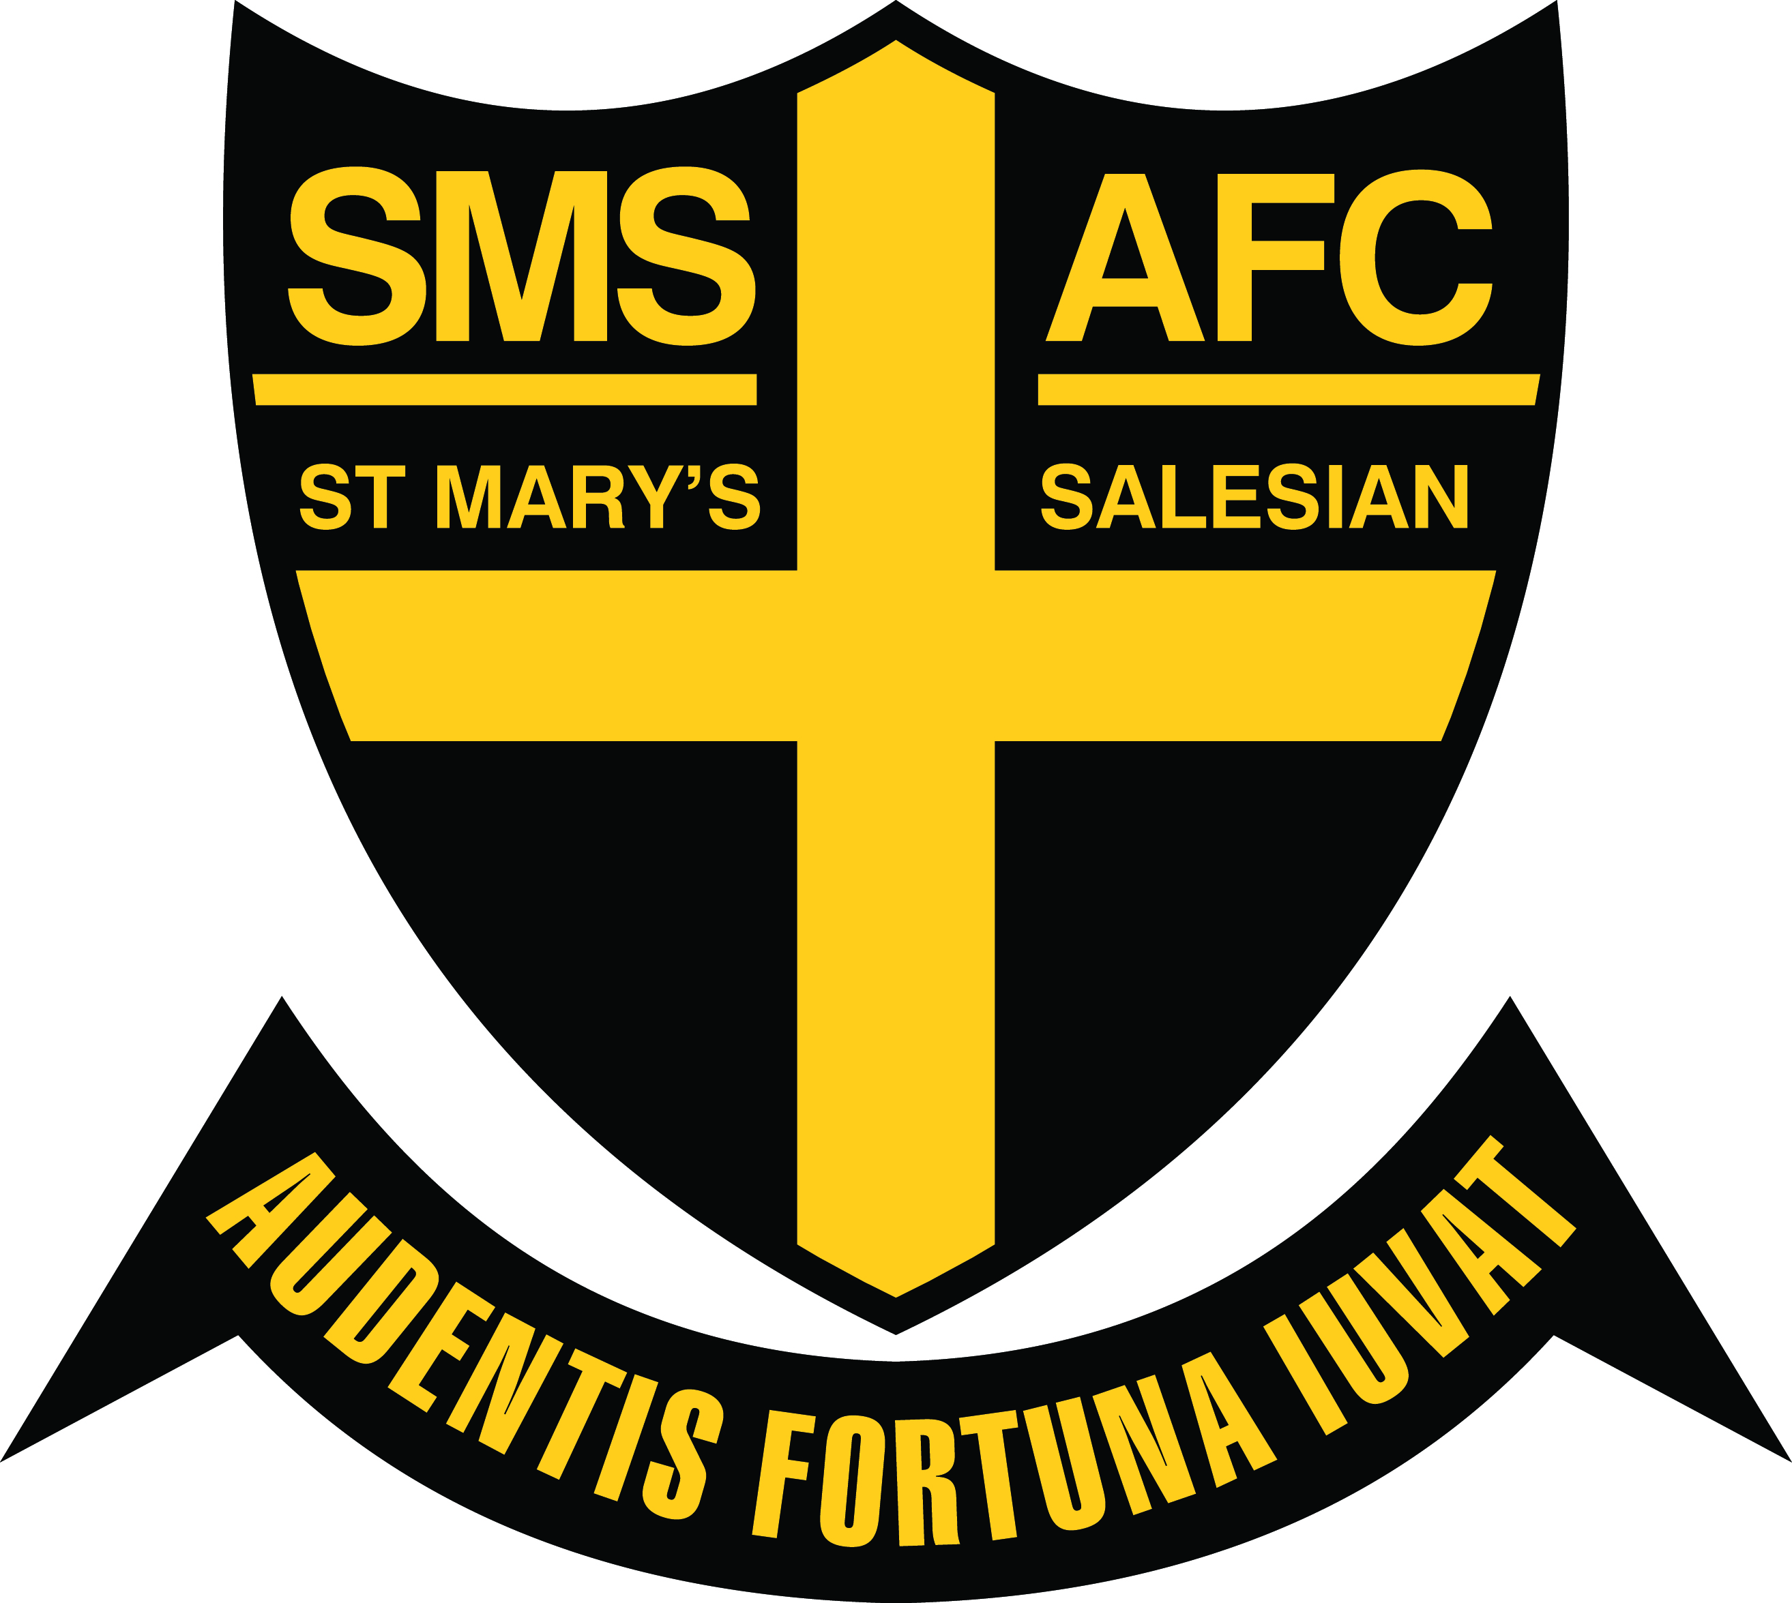

The St Mary’s Salesian Amateur Football Club seeks applications for the following positions:
Head Trainer:
Role:
- To coordinate the club trainers and arrange roster.
- Oversee the management of player injuries & rehabilitation
- Manage ordering of medical supplies.
- Mentoring & training of staff.
- Liaise with Club Physio and Senior Coaches
- Minimum Level 1 Sports Trainer Certificate
- Previous sports training experience required.
Sports Trainers:
- We require sports trainers to join our Medical Services Team for season 2018 and beyond. You will require a min Level 1 Sports Trainers Certificate.

- Remuneration will be negotiated for all roles.
- We operate a floating roster and can work in with work, uni & sport commitments.
- Training nights Monday, Tuesday & Thursdays, Matches Saturdays.
- We have 6 teams to service, 3 Senior Male, 2 Senior Women’s & under 19’s.

St Mary’s Salesian AFC is based in Glen Iris and competes in Premier C VAFA , we are a well-resourced and respected community club .Further details www.stmaryssalesianafc.com.au
Please forward applications to
David Malcolm
president@stmaryssalesianafc.com.au 0409 311 553
All enquires and applications treated in the strictest confidence.

