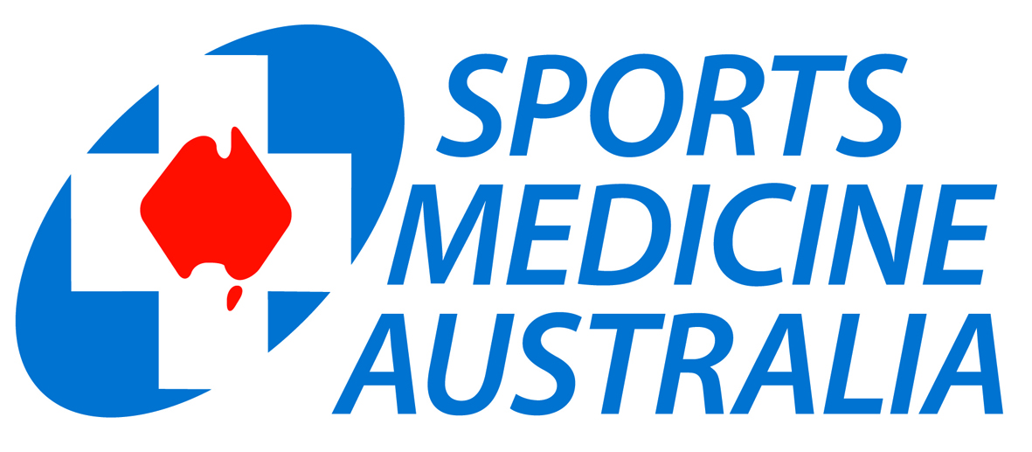

HLTAID004 Course Outline
Provide Emergency first aid response

in an education and care setting

This document has been developed for SMA SSP learners, administrators, trainers, and assessors.

This course has been designed to equip individuals with sound first aid skills which can be applied within the childcare and education environment or any other environment. Upon successful completion of all assessment tasks participants will receive a statement of attainment for HLTAID004 Provide emergency first aid response in an education and care setting, also incorporating HLTAID001 Perform Cardiopulmonary Resuscitation.

This is a blended learning program, consisting of online and class room activities.

Class room delivery
Students are required to attend the 1 day (Min of 8 hours face to face) classroom program.

First Aid Online

SMA provides blended learning using online First Aid theory training. The online program provides individual learning at the students own pace. This allows the learner to attend one full day (8 hours) of face to face training which consolidates the theory and provides practical scenarios, and theory and practical assessment.

Context of the course

HLTAID004 Provide emergency first aid response in an education and care setting is delivered by SMA as a contextualised course for the childcare and education environment. The online component provides generic knowledge, and the classroom delivery is contextualised to the educational and care workplace.

The following timetable demonstrates the delivery of the course in the classroom environment.

Students should make sure they arrive at least 15 minutes before the start time to ensure there is no delay in the start of the course. There is an allowance for short breaks in the morning and afternoon and a half hour lunch break.
Time | Modules | Practical Assessment
Pre-course  0830  1700 | Pre-course Online training module  (Everyday Learning)  Welcome and Admin  Course outline and assessments explained  Recap DRSABCD and CPR  Use of the Automatic Electronic Defibrillator (AED)  Practicals on adult, child and infant manikin  First Aid Emergencies  Cardiac conditions, Heart Attack, Stroke, Drowning, Choking and Airway Obstruction  Practical scenarios  Fractures and Dislocations, Soft Tissue Injuries,  Slings, Bandaging, Ricer, Immobilization  Practical scenarios Skin Injuries  Burns, Infections, Needle Stick, Bleeding, Bites and Stings, Amputation, Shock.  Practical Scenarios Injury Management  Eye and Ear Injuries, Head, Spinal, Abdominal and Crush Injuries.  Practicals Medical Conditions  Asthma, Seizures, Poisoning, Toxic Substances, Anaphylaxis, Diabetes.  Practicals Environmental Illness  Injury Reporting  Written Test and Practical Assessment  (Once this final assessment is completed, marked and student has handed in all the necessary paperwork students may leave) | Certificate of Completion required prior to the start of the face to face course.  DRSABCD  CPR & AED  CPR on adult, child and infant  DRSABCD, first aid procedures  Cardiac conditions, Heart Attack, Stroke, Drowning, Choking and Airway Obstruction, Verbal reporting.  Soft tissue management using “Rest Ice Compression Elevation Referral” (RICER) and arm sling for immobilization. Fractures, Dislocations, Sprains, Strains.  Wound care, Bleeding, Burns, Envenomation, Shock, Altered consciousness.  DRSABCD  Asthma, Respiratory distress, Seizures, Poisoning, Allergic reaction, Anaphylaxis, Convulsions, Diabetes  Complete written Injury report  Multiple choice test

Duration | Online component incorporating most theory requirements– learner’s own pace.  Classroom delivery min 8 hours including theory and practical.
Packaging | Learners will be assessed individually and will need to display competency in all assessable elements of HLTAID001 Provide CPR, and HLTAID004 to successfully complete the HLTAID004 accreditation.
Course Delivery | This course is delivered using blended learning and include a range of theoretical and practical tasks. Learners are required to participate in all elements of the course, providing them with the opportunity to practice and refine their skills prior to assessment.
Assessment | Learner assessment is conducted using a range of methods:  - Online questions (90 questions embedded within the online learning module) requiring 100% correct answers.  - Written test completed in class requiring 100% correct answers.  - Practical assessment using scenarios.  - Completion of a written Injury report form.  Assessment may be conducted during the scenarios after each section, depending on student competency.
Validation | The materials for this course have been through a validation process involving several key experienced stakeholders and industry experts.  Validation is part of the continuous improvement strategy of this RTO and regular validation and moderation activities occur within each branch.
Content | The course content and assessments meets the requirements of the HLTAID004. It includes CPR and first aid knowledge and practical skills.
Pre course work | Students are required to complete an online learning module prior to the course. A certificate of completion is issued after successful completion of the online course, and is to be provided to SMA prior to attending the classroom component.
Post course work | No post course work is required.
Trainers and  Assessors | SMA draws on its network of professional sports trainers, sports doctors, physiotherapists, and other health care professionals to deliver and assess Safer Sport Program courses.  Trainers are required to hold:  - TAE40110 Certificate IV Training and Assessment or equivalent  - An Advanced first aid qualification or at least three years’ experience as a health professional, nurse or emergency services provider.  - Current vocation experience and recent professional development  - Police clearance or working with children card
Certificates | Learners should expect to receive Statements of Attainment for HLTAID004, incorporating HLTAID001 Provide Cardiopulmonary Resuscitation, within two working weeks of successful course completion.
Resources | Learning resources  - First Aid Manual  - Access to Online Training Course  - AED, epipen/anapen, spacers, bandages, slings and other basic first aid items relevant to the assessments  - Manikins (adult, child and Infant), antibacterial wipes, gloves and disposable face shields  Resources are provided by SMA.
Context | This course structure involves the use of simulated scenarios which reflect real life situations occurring in the workplace or in the education and care working environment. This is intended to allow the students to demonstrate application of their skills and knowledge as is required in the training package rules.
Further Accreditation | Participants are welcome to attend future SMA courses such as:  - Level One Sports Trainer  - Specific issues of prevention, assessment, management of and recovery from sports injury  - Examine how the extent and intensity of sports participation relates to the incidence of sports injuries  - Explore the range of technical and scientific approaches for maintaining the wellbeing of athletes  - Other SMA courses include:  - Advanced Taping – Shoulder and Knee etc  - Level Two Sports Trainer  - Introduction to Sports Massage  - Spinal Injury & Concussion Management
Policies | Please ensure that you have read and are familiar with all our policies. These can be found on the registration form and the Sports Medicine Australia website: http://sma.org.au
Special needs and LLN reasonable adjustment | Learners are requested to advise SMA at enrolment, where additional support for special needs or language, literacy and numeracy (LLN) needs may require adjustment of the training delivery and assessment. SMA will provide adjustment to support those needs.
Behaviour expectations | Sports Medicine Australia endeavours to provide a learning environment, which is supportive of group and individual learning. This requires support from all participants, presenters and course convenors. It is therefore expected that participants will behave in a manner, which is respectful of fellow participants and Sports Medicine Staff.
Parking | You will receive further information on parking for the venue where your course is being held prior to the course.
Dress | Please wear comfortable clothing, as you will be expected to participate in practical activities throughout the course.
What to bring | Pens and notepaper. Manuals will be supplied where required.  Certificate of completion for the online component must be provided.
Entry | Participants must be a minimum of 14 years old to enrol in this course.

